Embracing Complexity Major Speaking Assignment 1 — Discovering Our Superpowers

Assignment Design Credit: Sonja Mayrhofer, Ashley Wells, Megan Knight, IDEAL

Description:
As a class, we have followed Kamala Khan’s journey in discovering her superpowers and learning to use them to fight evil villains that threaten her community of Jersey City. For this speech assignment, you will identify what communities you belong to and discover how your own superpowers (or skills) can contribute to those communities. This speech follows an I-Search template, meaning you will present not only your findings on speech day, but you will also share with us the process arriving at your conclusions. In other words, you will describe your superpowers and how you discovered them.

To help us better understand the origin story of your superpowers, community involvement, and speech itself, you will create a Prezi (prezi.com) that charts the process of interrogation. The Prezi will be a visual aid for your speech. Show us the journey.

Objective:
This assignment prompts you to exercise your critical thinking skills while practicing some preliminary research strategies that will come in handy with later assignments and activities. Here we are making valuable connections with what we’ve read and who we are.

Due: Week 7 (see speech schedule for your presentation date)

Value: x % (of final grade)

Length: 5-6 minutes

Due Dates & Deadlines

Due Dates | What to do?
Week 5 & 6 | - Participate in brainstorming and group work activities to focus your presentation in Weeks 5 & 6  - Your topic proposal will be due, online and in class, on x/x
Week 6 | Speech 1 Workshop:  Upload a copy of your outline before class. This outline does not need to be complete but should demonstrate thoughtful progress towards speech goals. It should include your tentative thesis, your developing arguments, and your examples. Present your speech-in-progress to your workshop partners. The more complete your speech is on workshop day, the better feedback your partner will be able to provide  Please Note: Failure to come prepared to workshop day will result in an automatic deduction equal to a full letter grade. Failure to attend workshop day will result in an automatic deduction equal to two full letter grades.
Week 7: | Final Copy Due!  - Upload the final copy of your outline and your Prezi into the appropriate ICON dropbox before class  - Deliver your Presentation

Assignment Process:

I-Search is an alternative to the traditional research assignment, in which the student “conducts a search to find out something he [sic] needs to know for his own life and writes the story of his adventure.” ––Ken Macrorie, The I-Search Paper

This assignment, following the I-Search template, will involve multiple steps: you will pose a research question, devise a plan for answering that question, conduct research, and document the process. Finally, you will share your investigative story and findings in the first person. We will accomplish all these steps in the following way:

- Identify Your Communities (adapted from IDEAL’s “Show What You Know” Assignment):
Establish context before you frame your own research question: What are my superpowers? Think of different groups or communities that shape you, your world view, your interests, your talents, your abilities. What makes a group a community? What role do you play in this community? Try to define and describe them using the attached work sheet.
- Identify Needs in Your Communities:
Once you have defined and described your communities, frame your research question, involving ONE of these communities’ needs. This involves narrowing your research focus. So, you are starting with several varied and, at times, overlapping communities. You are now deciding on one to turn your attention to.

But first you need to consider whether any of these communities need support or could benefit from your assistance in some way. What community might particularly benefit from a superhero? This step will require thought and research. You might have to look at organization websites, current/past news articles, and other resources (such as interviewing an expert) to identify these needs. Document your research process in a journal and/or keep track of your assembled resources in an annotated bibliography. Make sure you include them in a Works Cited List (following MLA guidelines) along with your final speech.

While your questions might shift and change as you perform your research, analysis, and mapping, you should arrive at a thesis.
- Identify Your Role in Addressing Community Needs:
Which skills (or “superpowers”) are needed to address your community’s needs? Try to define these skills and consider whether you already have those skills or need to acquire them in order to address the specific need. Develop a plan of action to acquire these skills and put them into action to help your chosen community. In other words, tell us your origin story.

- The Final Speech:
Your speech should have a clear sense of organization, with an introduction, body, and conclusion. Begin with a thesis statement that identifies your chosen community and your role in it. Develop your body according to your “research narrative” and tell your story in the first person: How did you become part of your community? What are your community’s needs? What’s your current role in this community? How did the sources you discovered in your research shape your search for an answer to your question? How might your role change now that you have done more research? What kind of self-reflection occurred? Where you aware of this superpower prior to the project?

Expectations for your speech:
- Your Prezi should detail the “research narrative” in a creative and expressive way. Make it your own by incorporating images of yourself in your community, music that represents the culture of your community, or photos of artifacts or screenshots of important text you find during your research process.
- Deliver your speech in a conversational mode, in the first person. You may use 3-4 note cards that contain an outline, but do not read from the script.
- Your speech (in total) should be 5-6 minutes long.
- Demonstrate your knowledge of the rhetorical techniques we’ve learned so far. Be sure to explain terms your audience may not know — keep in mind that your classmates may not be familiar with the community you are describing.
- Craft a clear thesis defining your community and your ability to help this community.
- Provide clear transitions between sections. Create a speech that is easy for your listeners to follow. Your Prezi should contribute to this sense of organization, structure, and clarity.
- Use seamless quote integration and verbal citations.

Additional Resources for Speaking:
- Remember that the Speaking Center (410, 412 & 414 EPB, (319) 335-0205, www. speakingcenter.uiowa.edu) can help you at any stage of your speech. This is a free resource to students.
- Visit IDEAL in 108 EPB for help with your Prezi.
PERSONAL KNOWLEDGE COMMUNITIES: YOUR COMMUNITIES (From IDEAL’s “Show What You Know”)

Use this sheet of paper to create a map of communities of which you are a part. Include at least 5 communities. For each community include answers to the following questions:
- Did you choose to be a part of the community?
- What, if anything have you learned from being a part of the community?

PERSONAL KNOWLEDGE COMMUNITIES: YOUR COMMUNITIES EXAMPLE (From IDEAL’s “Show What You Know”)

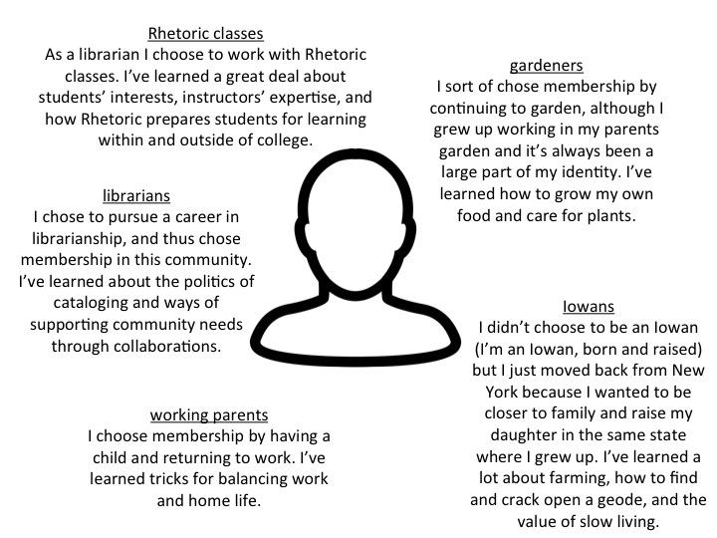

Creative Commons Licensing

This assignment is licensed under a Creative Commons Attribution 3.0 License. Anyone in the world is free to read, download, adapt, change, translate, and share it with others. The only condition is that you attribute the assignment to Iowa Digital Engagement and Learning (IDEAL.uiowa.edu), Ashley Wells, Sonja Mayrhofer, and Megan Knight: give appropriate credit, provide a link to the license, and indicate if changes were made. You may do so in any reasonable manner, but not in any way that suggests the licensor endorses you or your use. For more information on copyright click here

