ACTIVITY #1: WHAT IS A COMMUNITY?

Use Google or Bing News to locate two examples of how communities are discussed. Record the sentences you find in which the word community is used. Include a link and citation to the original source.

- Description 1

- Description 2

Use University of Iowa Libraries Smart Search to locate two non-dictionary resources that define the term community. Record the definitions provided in each resource and a citation for each. See this video [coming soon] for an example of how to use these databases to complete this task.

- Description 1

- Description 2

Based on the descriptions you located, develop a short (1-2) sentence definition of community:

ACTIVITY #1: WHAT IS A COMMUNITY? EXAMPLE

EXAMPLE: Use Bing news to locate 1-2 non-dictionary resources that define the term community. Record the definitions provided in each resource and a citation for each.

- “This small, close-knit community is a picture of rural America, with stubble-filled cornfields and a Main Street lined by churches, shops and sidewalks. It’s also the likely epicenter of the largest outbreak of HIV, the AIDs virus, in Indiana's history.” Ungar, L & Kenning, C. (2015, April 15). Indiana community’s HIV outbreak a warning to rural America. USA Today. Retrieved from: www.usatoday.com
  - Town (geographic)
  - Small
  - Close-knit
  - Problems
- “Tomallo noted Lakewood is known for its larger per capita LGBT community, and the idea to host a forum was sparked by the questions, “What is Lakewood doing to attract LGBT individuals and families?”” Price, K. (2015, April 15). Lakewood Alive forum focuses on Lakewood’s level of equality for the LGBT community. Cleveland Sun News. Retrieved from: www.cleveland.com
  - Identity

Use JSTOR to locate 2-3 non-dictionary resources that define the term community. Record the definitions provided in each resource and a citation for each.

- “A learning community (LC) weaves together the learning, skills, and assignments of two or more classes into a unified mosaic of educational objectives by blending the instruction of logically related disciplines.” Dodge. L. & Kendall, M.E. (2004). Learning Communities. College Teaching (52)4, 150-155.

- “The author found personal community in his professional organization.” “My community consists of my fellow graduate students, and together we commiserate on which panels to listen to, look for the parties where there will be free food, share hotel rooms. My community comes with me.” Villanueva, V. (2011). Of kin and community. The English Journal (101)1, 108-110.

Based on the descriptions you located, develop a short (1-2) sentence definition of community:

A community is a way to describe a group of people who share similar characteristics, ideas or identities.

ACTIVITY #2: YOUR COMMUNITIES

Use this sheet of paper to create a map of communities of which you are a part. Include at least 5 communities. For each community include answers to the following questions:
- Did you choose to be a part of the community?
- What, if anything have you learned from being a part of the community?

ACTIVITY #2: YOUR COMMUNITIES EXAMPLE

Use this sheet of paper to create a map of communities of which you are a part. Include at least 5 communities. For each community include answers to the following questions:
- Did you choose to be a part of the community?
- What, if anything have you learned from being a part of the community?

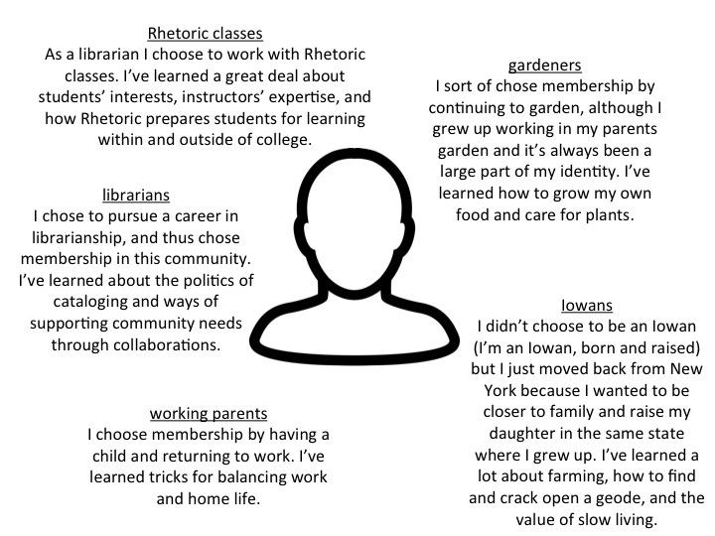

ACTIVITY #3: WHAT DO YOU KNOW?
Choose one of the communities you identified in Activity #2. Now make a list of things you’ve learned as part of that community and describe the different types of activities that contributed to your learning. The following list describes three types of activities (or knowledges) that can contribute to learning within a community. Please describe two examples of each of the following types of activities.
- Social activities - these are types of knowledge gained through understanding values and attitudes of a particular community (e.g., expectations about keeping a shared workspace clean)
- Physical activities - these are activities that involve actions of the body and/or interactions with physical materials (i.e.,
- Textual activities - these are activities that incorporate texts of some kind (i.e., books, magazines, blogs)

ACTIVITY #3: WHAT DO YOU KNOW? EXAMPLE
Choose one of the communities you identified in Activity #2. Now make a list of the different types of knowledge that helped you learn something in that community. Try to come up with at least two examples of each type of knowledge listed below.
- Social activities - these are types of knowledge gained through understanding values and attitudes of a particular community (e.g., expectations about keeping a shared workspace clean)
- Physical activities - these are activities that involve actions of the body and/or interactions with physical materials (i.e.,
- Textual activities - these are activities that incorporate texts of some kind (i.e.,

- Social
  - My parents (and grandparents) encourage experimentation while planting gardens as they know that no matter how well you plan the unexpected can always happen.
  - Participating in gardening communities I’ve learned the value of homegrown food and that sharing food with other people is a really great way to make new friends and build community.
- Physical
  - Through digging and planting seeds in early spring I’ve learned how to sense, through touch and smell, when soil is warm enough and moist enough for planting.
  - In harvesting and preparing plants for meals I’ve become better at knowing when a plant is ready to eat based on its smell, appearance, and feel.
- Textual
  - Reading seed packets I’ve learned what information tends to be included on the packets (e.g., seed depth, plant height, etc.) and how to follow planting guidelines, like how much space to leave between rows.
  - Reading gardening books I’ve learned a few scientific names of plants and also what plants are mutually beneficial when planted near.

ACTIVITY #4: DEVELOPING AUTHORITY
Return to the information you shared in Activity #3 and for each entry list identify the ‘authors’ of each type of knowledge you listed. How did you know or come to trust these authors to teach you about your chosen topic? From your experience in this community, do you now have the authority to teach about this topic? Why or why not?

ACTIVITY #4: DEVELOPING AUTHORITY EXAMPLE
Return to the information you shared in Activity #3 and for each entry identify the ‘authors’ of each type of knowledge you listed. How did you know or come to trust these authors to teach you about your chosen topic?

- Social
  - My parents (and grandparents) encourage experimentation while planting gardens as they know that no matter how well you plan the unexpected can always happen.
    - Authors: Parents & grandparents. I trusted their knowledge because of their previous experience. My parents were both raised on family farms, as were my grandparents. They grew up growing plants and tending animals. I trusted that their experience taught them well.
  - Participating in gardening communities I’ve learned the value of homegrown food and that sharing food with other people is a really great way to make new friends and build community.
    - Authors: Gardening community members. I trusted their knowledge because they shared information with me that helped me solve problems (like how to take care of pests organically).
- Physical
  - Through digging and planting seeds in early spring I’ve learned how to sense, through touch and smell, when soil is warm and moist enough for planting.
    - Authors: Soil + my own experience. I trust that the trends I’ve noticed and the success I’ve had in growing confirm that my knowledge of soil quality has improved.
  - In harvesting and preparing plants for meals I’ve become better at knowing when a plant is ready to eat based on its smell, appearance, and feel.
    - Authors: Plants + my own experience. I trust that the trends and tricks I’ve developed confirm that my knowledge of plant harvesting and preparation have grown.
- Textual
  - Reading seed packets I’ve learned what information tends to be included on the packets (e.g., seed depth, plant height, etc.) and how to follow planting guidelines, like how much space to leave between rows.
    - Authors: Seed company employees. I assume that anyone hired to write text for seed packets is qualified and that their work is edited and vetted by similarly knowledgeable employees.
  - Reading gardening books I’ve learned a few scientific names of plants.
    - Authors: While I don’t have names of specific authors, I assume that most authors writing gardening books have degrees in horticulture (or related science topics) that prepare them to write knowledgeable and factual books.

From your experience in this community, do you now have the authority to teach about this topic? Why or why not?:

I have many years of experience growing my own food however I would not feel comfortable teaching about the more scientific aspects of plants or growing food. I don’t have enough formal training to teach about the scientific aspects of plants and/or growing food. However, my decades of experience prepare me to teach others basic growing tips, including how to choose plants best suited to individual needs/space/soil quality.

Creative Commons Licensing

This assignment is licensed under a Creative Commons Attribution 3.0 License. Anyone in the world is free to read, download, adapt, change, translate, and share it with others. The only condition is that you attribute the assignment to Iowa Digital Engagement and Learning (IDEAL.uiowa.edu) and the University of Iowa Libraries (www.lib.uiowa.edu): give appropriate credit, provide a link to the license, and indicate if changes were made. You may do so in any reasonable manner, but not in any way that suggests the licensor endorses you or your use. For more information on copyright click here

